Safes Series D
Certified burglary protection according to EN 1143-1 Grad IV

Type | Dimensions ext. (mm) |  |  | Dimensions int. (mm) |  |  |  | Weight/Vol |  | Shelves
 | H | L | P | H | L |  | P | Kg/litres
Certified burglary protection according to EN 1143-1 Grad IV
D94/40 | 1160 | 610 | 620 | 940 | 402 | 335 |  | 541/144 | 1
D104/40 | 1260 | 610 | 620 | 1040 | 402 | 335 |  | 579/158 | 1
D124/40 | 1460 | 610 | 620 | 1240 | 402 | 335 |  | 655/188 | 2
D144/40 | 1660 | 610 | 620 | 1440 | 402 | 335 |  | 730/218 | 2
D94/60 | 1160 | 810 | 730 | 940 | 602 | 445 |  | 765/277 | 1
D104/60 | 1260 | 810 | 730 | 1040 | 602 | 445 |  | 817/306 | 1
D124/60 | 1460 | 810 | 730 | 1240 | 602 | 445 |  | 921/363 | 2
D144/60 | 1660 | 810 | 730 | 1440 | 602 | 445 |  | 1025/420 | 2
D164/60 | 1860 | 810 | 730 | 1640 | 602 | 445 |  | 1129/477 | 3
D184/60 | 2060 | 810 | 730 | 1840 | 602 | 445 |  | 1233/534 | 4
D94/75 | 1160 | 960 | 790 | 940 | 752 | 505 |  | 936/388 | 1
D104/75 | 1260 | 960 | 790 | 1040 | 752 | 505 |  | 999/428 | 1
D124/75 | 1460 | 960 | 790 | 1240 | 752 | 505 |  | 1124/508 | 2
D144/75 | 1660 | 960 | 790 | 1440 | 752 | 505 |  | 1250/588 | 2
D164/75 | 1860 | 960 | 790 | 1640 | 752 | 505 |  | 1375/668 | 3
D184/75 | 2060 | 960 | 790 | 1840 | 752 | 505 |  | 1500/748 | 4
D194/75 | 2160 | 960 | 790 | 1940 | 752 | 505 |  | 1563/788 | 4
D164/100 | 1860 | 1210 | 790 | 1640 | 1002 | 505 |  | 1762/879 | 3
D184/100 | 2060 | 1210 | 790 | 1840 | 1002 | 505 |  | 1923/984 | 4
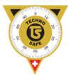
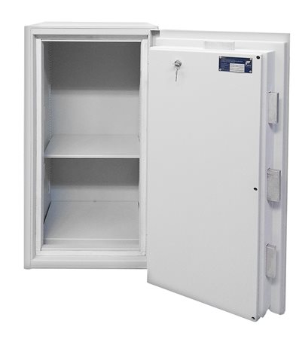
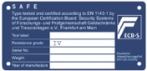
TECHNO SAFE Coffres-forts
Avenue Industrielle 5, 1227 Carouge
+41 22 343 21 14
info@technosafe.ch / www.technosafe.ch

Made in Switzerland

Technical data :
- Innovative shielding
- Solid locking on all sides
- Lock and bolts are blocked in the event of a break-in attempt
By informer lock
- Electronic lock with Paxos redundancy
- Removable shelves
- Pre-equipment for alarm
- Colour: Light grey RAL 7035
- Door pivots on the right
- Device for fixing to the floor
- Made in Switzerland

Options :
- Other locks on request
- Two locks compulsory from Class IV onwards
- Special colours

