DWS safes - DWS-F
Certified burglary protection according to EN 1143-1 Grad IV
DWS-F: Certified fire protection according to EN 15659 LFS 60P
Type | Dimensions ext. (mm) |  |  | Dimensions int. (mm) |  |  | Weight/Vol | Shelves
 | H | L | P | H | L | P | Kg/litres
Certified burglary protection according to EN 1143-1 Grad IV
DWS 0849 | 848 | 645 | 565 | 695 | 495 | 320 | 635/110 | 1
DWS 0850 | 848 | 810 | 725 | 695 | 660 | 480 | 875/220 | 1
DWS 1000 | 1003 | 810 | 725 | 850 | 660 | 480 | 1030/269 | 2
DWS 1200 | 1193 | 810 | 725 | 1040 | 660 | 480 | 1150/329 | 2
DWS 1600 | 1538 | 810 | 725 | 1385 | 660 | 480 | 1405/439 | 3
DWS 1901 | 1883 | 810 | 725 | 1730 | 660 | 480 | 1680/548 | 4
DWS 1903 | 1883 | 1110 | 725 | 1730 | 960 | 480 | 2090/797 | 4
DWS 1902 | 1883 | 1110 | 725 | 1730 | 960 | 480 | 2130/797 | 4
DWS 1904 | 1883 | 1415 | 725 | 1730 | 1265 | 480 | 2550/1050 | 4
Certified burglary protection according to EN 1143-1 Grad IV
DWS-F: Certified fire protection according to EN 15659 LFS 60P
DWS-F 0850 | 848 | 810 | 725 | 695 | 660 | 480 | 875/220 | 1
DWS-F 1000 | 1003 | 810 | 725 | 850 | 660 | 480 | 1030/269 | 2
DWS-F 1200 | 1193 | 810 | 725 | 1040 | 660 | 480 | 1150/329 | 2
DWS-F 1600 | 1538 | 810 | 725 | 1385 | 660 | 480 | 1405/439 | 3
DWS-F 1901 | 1883 | 810 | 725 | 1730 | 660 | 480 | 1680/548 | 4
DWS-F 1903 | 1883 | 1110 | 725 | 1730 | 960 | 480 | 2090/797 | 4
Profondeur : + 60 mm pour charnières
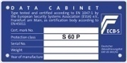
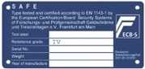
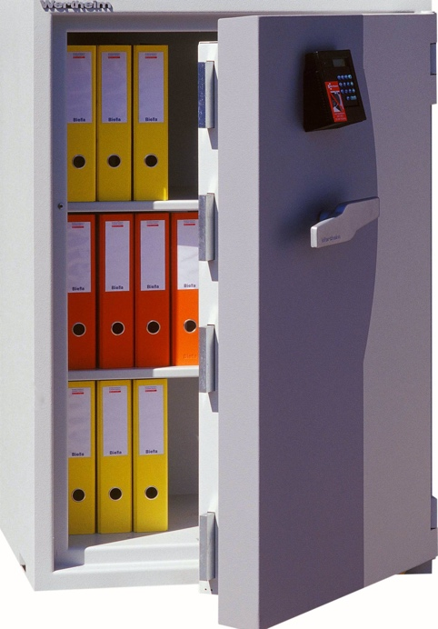

It simply has no weak points

Technical data :
- Fire test 60 minutes
for paper (models DWS-F)
- Solid locking on all sides
- Multi-wall construction
- All sides reinforced with material
extremely resistant
- Sensitive points protected by
additional reinforcements
- Shielding of the locking system
- Locking of the lock and bolts in
test case of burglary by means of an informer lock
- Alarm pre-equipment
- Device for floor and wall mounting

Standard finish :
- Electronic locks (Paxos)
- Removable shelves
- Two-tone grey RAL 7035 and RAL 7045
- Door pivots: right or left
DWS 1902 and DWS 1904 with two doors

Options :
- Other locks on request
(two mandatory locks at
From Class IV onwards)
- From model 1600 upwards: available
with bank compartments
- Available with anti-drilling by
diamond crown
- Available in modular version
(DWS models from size 1000 upwards)
- Special colours
- Interior fittings according to
the price list

TECHNO SAFE Coffres-forts
Avenue Industrielle 5, 1227 Carouge
+41 22 343 21 14
info@technosafe.ch / www.technosafe.ch

DWS 1200

